# Version

Rev 1.0

@jbroughton

# User Story

I need a method by which I can quickly and easily calculate, in a browser, product gap and pitch. This is a calculation I do a lot while simulating a system; this extension will keep the process immediate.

# Description

On icon click, a form will pop up asking the user for a brake speed in feet per minute (FPM), a meter speed in FPM, and a product size (length or diameter in inches). A “Calculate…” button press will display the BMB ratio (often used to size motors – a “power take off” or “PTO”), the expected gap, and the expected pitch.

# Definitions

A very common component (term used loosely) in the manufacturing world is a brake/meter belt (BMB). This component consists of two adjacent conveyor belts that run at different speeds; the first of the two is the brake. The brake always runs slower than the meter. The effect is induction of a gap between back-to-back products.

The “pitch” of these metered products is the point-to-point distance; that is, distance between one product’s leading edge to the next upstream product’s leading edge – gap plus length (or diameter).

# Architecture

The IM_Chrome extension will be a very simple browser extension to Chrome.

# Development

The project will be hosted on Github, using Git as its version control here: https://github.com/subhoney/IM_Chrome

IM_Chrome will include a custom icon!

Testing will include equivalence classes for positive, negative, zero, very large and very small numbers. Five test cases per arithmetic calculation should be written.

# Sequence Diagram

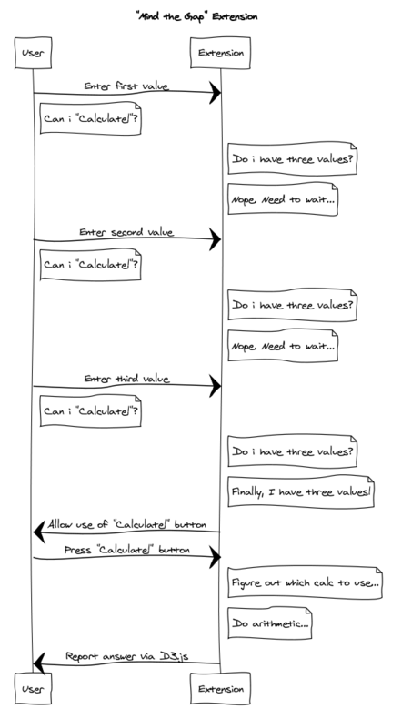

# Wireframe

